**Python programming**

Lab-1

1.Writing a program to print a welcome message.

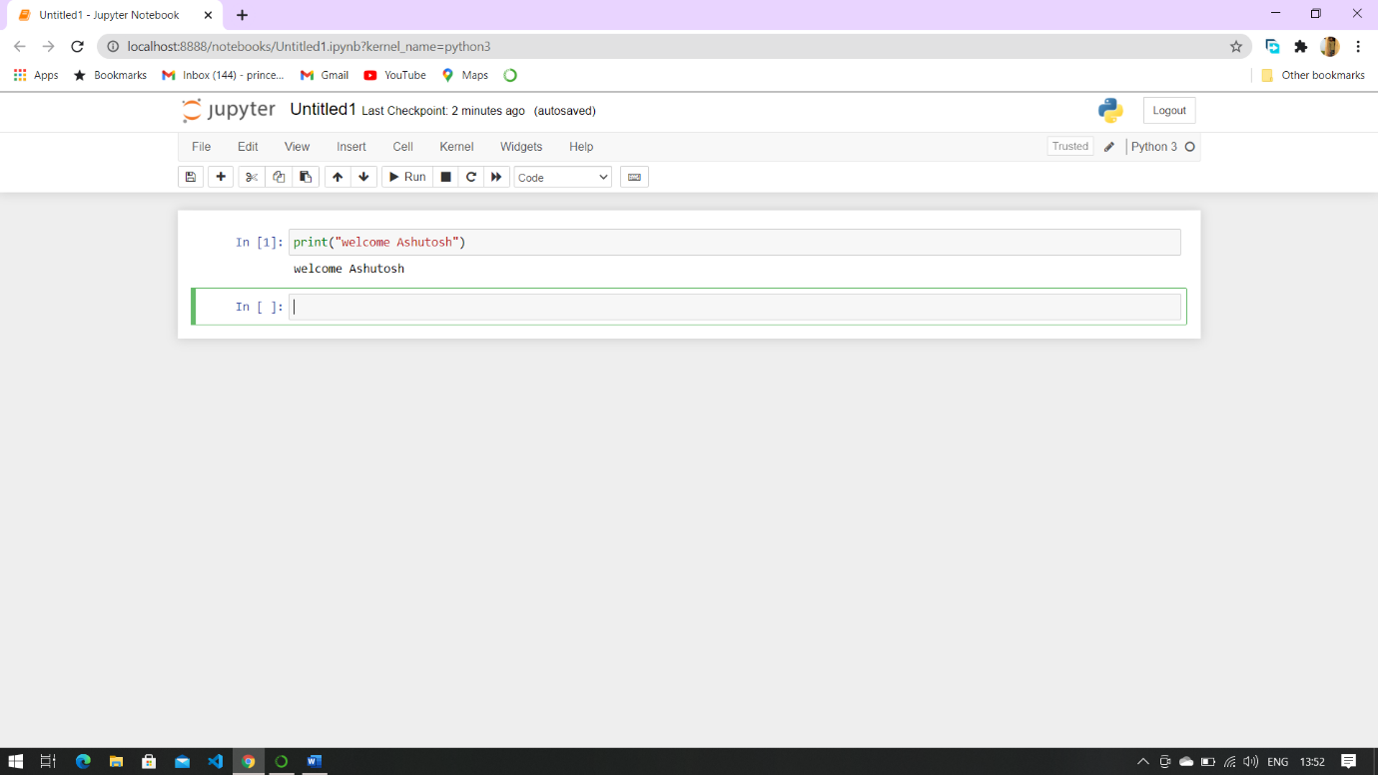

2.Write a program to add two numbers.

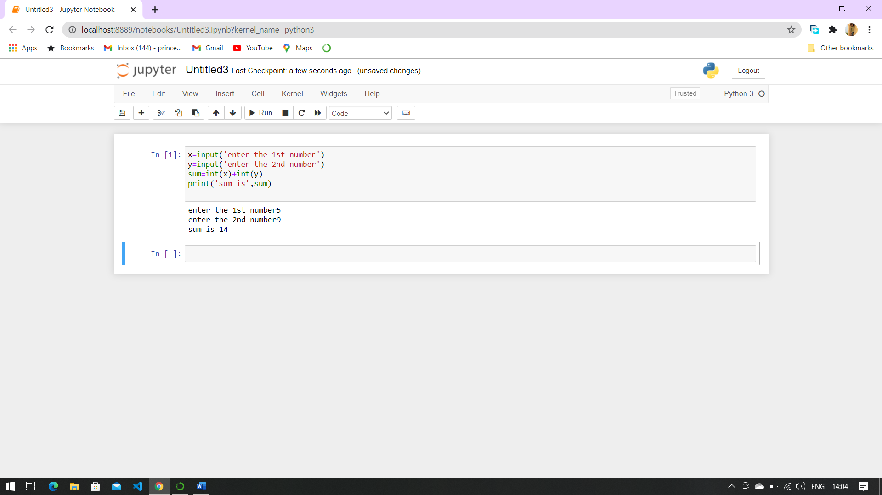

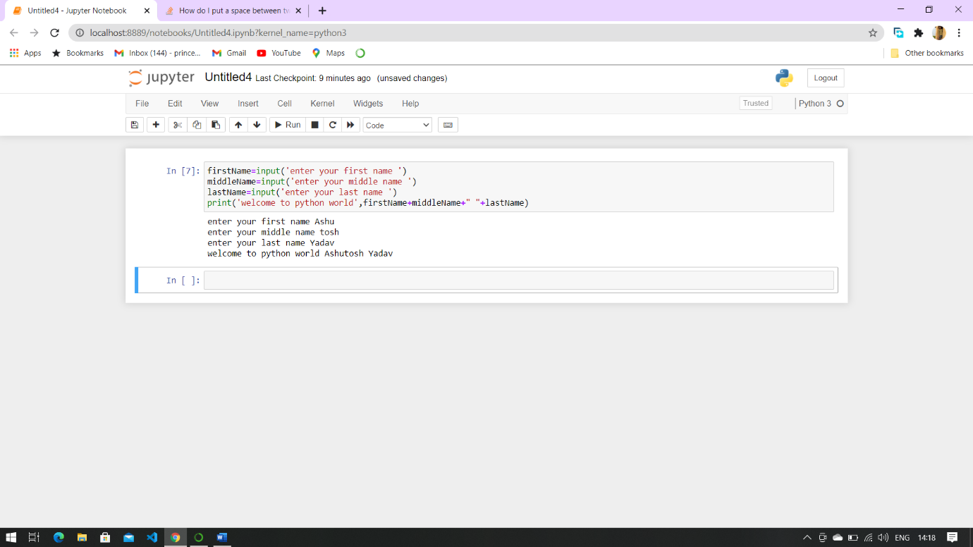3.Write a program to take first name, middle name and last name from the user. Greet the user.